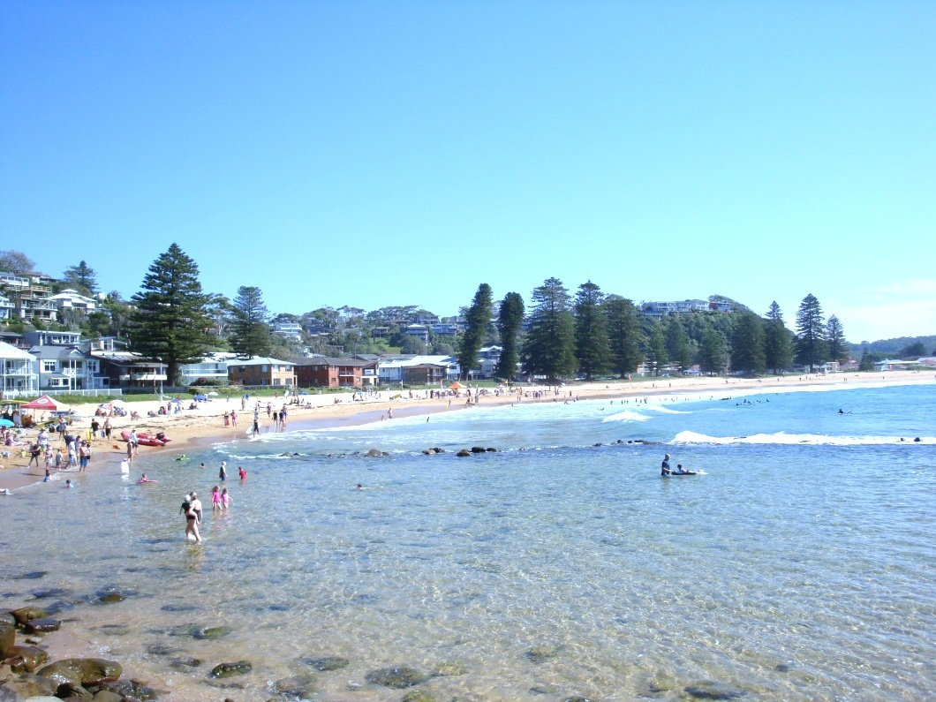
Probus Club of Avoca Beach Inc. NEWSLETTER


Issue: 397 Monday 19th October 2026
Life Members : Roy Crump, Dennis Elliott,  Jan Heinrichs , Jock Plimmer, Barry Porter.,  Management Committee  President: Peter Ayton 0404 615 090  Vice President: Pamela Spencer 0400 396 542  Secretary: Dorothy Harper 0419 310 685  Treasurer: Joan Flynn 0419 997 573  Guest Speakers: Peter Mear 0401 346 824  Membership: Sue Roe 0422 771 070  Asst Secretary Barbara Chalmers 0427428 721  Asst Treasurer Maureen Bell 0409 778 141  Asst Editor Barry Tobin 0417 260 833  Asst Membership Joan Flynn 0419 997 573  Asst Guest Speaker John Evans 0414 997 273  Social Activities: Paul McInnes 0412 524 815  Catering Liaison: Sue Roe 0422 771 070  Editor & Printing Dennis Elliott 0412 049 020  Immediate Past Pres Barry Tobin 0417 260 833  Ancillary Appointments  Attendance:& Welfare Sue Elliott 0425 234 725  Social Activities: Jenny Lucas 0411 021 913  Val Allen 0433 131 774  Judith McDonald 0412 795 620  Catering Team Joy Kuiters 0432 684 445  Jan Johnson 0407 631 686  Raffles (Meetings): Wendy Noonan 0416 286 787  Jan Johnson 0407 631 686  Raffles (Barbecues): Merrilyn Self 0404 072 065  Sue Elliott 0425 234 725  Book Exchange: Joe Panozzo 0458 130 338  Website & Email Barry Porter 0432 697 490  Auditor & Pub Officer: Jock Plimmer 0427 877 851  Printing/Production Dennis Elliott 0412 049 020  Probus Ambassador: Barry Porter 0432 697 490  Interest Group Convenors  Golf Group Convenor: Jock Plimmer 0427 877 851  Mexican Train Group: Yvonne Hollis 0409 030 304  Mexican Train Group Barry Tobin 0417 260 833  Walking Group Jeanette Anderson 0422 161 893  10 Pin Bowling John Hart 0402 020 026  EMERGENCY TELEPHONE NO  Social functions- Paul McInnes 0412 524 815  TODAY’S GENERAL MEETING  10:15am at Avoca Beach Bowling Club  Guest Speaker:  Tom Millar and Search Dogs from VRA Rescue NSW  NEXT GENERAL MEETING  16th November 2026 | FROM THE PRESIDENT  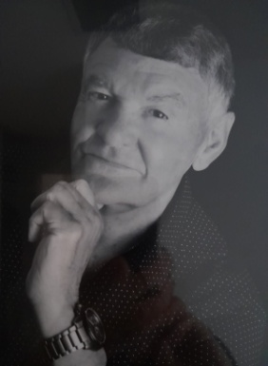  My Fellow Members,  On the 7th September 22 members attended a well organised and enjoyable BBQ/PICNIC at Kincumber Mountain reserve.  A truly tranquil location showcasing one of the many scenic spots on our beautiful Central Coast.  Well done to Sue, Jan and Joy, also cooks Joe Panozzo and John Hart.  I can still smell the onions, and enjoyed the excellent homemade coleslaw by Jan!  22 members attended the Postman’s run on the beautiful Hawkesbury River, enjoying a pleasurable morning including Anzac biscuits and a superb Ploughmans lunch.  Thank you Paul, Jenny and Judith for your organisation.  Our speaker for September, Peter Rae, gave an excellent insight into wartime preparations along the shores of Broken Bay and The Hawkesbury.  We look forward to his informative cruise next year, taking in Brisbane Waters, where over 1500 boats were built at the turn of the century.  A special thank you to Jock Plimmer, our “This is your Life” presenter for September. Well done Jock for an insight into your life.  Future speakers for their Life talk include :: John Hart, Joe Panozzo and Barry Tobin.  Congratulations to our future Secretary in training, Barbara Chalmers. The “L” plates can come off now for 2027/2028.  From the committee meeting on 28th September ….  The fun continues. It was unanimous to continue (Heads and Tails) at each general meeting and win that $20 Cole’s voucher.  Yours in fun friendship and fellowship.  Peter Ayton.  Compromise: The art of dividing a cake in such a way that everybody believes they got the biggest piece
  PROBUS CLUB OF AVOCA BEACH INC.
  PO Box 14 Avoca Beach NSW 2250
  avocaprobus@gmail.com
  www.probussouthpacific.org/microsites/avocabeach
  General Meetings: 3rd Monday of the month
  This Newsletter is for information of members of the Probus Club of Avoca Beach Inc. and other Probus Clubs and is not to be used for any other purpose
  The Newsletter is available on the club website

 | Social Activities  Program  2026 | 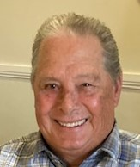
If Possible, Please pay to attend social functions by online banking, or by cheque. Bank Details are Westpac: BSB 032 596 Acc No 147818
Use your name plus the 4/5 letter function code

To add, alter or cancel booking please Contact
Social: Paul McInnes 0412 524 815 or
Jenny Lucas 0411 021 913
BBQ’s & Pub Lunches: Sue Roe 0422 771 070
Meeting Apologies: Sue Roe 0422 771 070

If paying by Cash at the meeting: Please place exact money in a sealed envelope indicating Name, Event and amount tendered for each separate event. (envelopes will be provided if needed.)
Monday 19 October | General Meeting at Avoca Beach Bowling & Recreation Club; 10.15 am. Lunch at The Table Restaurant, ABBRC. Own cost. | No bookings required
Friday 23rd October | Enjoy an outing to The Sydney Aquarium & Madam Tussauds  $39 for one $49 for both attractions. Travel using our opal cards & Lunch at own cost. Train from Gosford 9:34 Woy Woy 9:42 Carriage 3  Attendees to pay at the venue | Bookings and Payment  Contact: Paul McInnes | AQUA
Monday 26 October  (Put back from the 12th due to weather) | Probus Day Special Barbecue - "Fish and Chips" at 11am at Hunter Reserve (near theatre), Avoca Drive, Avoca Beach. Cost: $5. Pre-booking and cancellation advice essential. Celebrate Probus Day. Come dressed in our Probus colours of blue and yellow. Prizes to be won for the most creative ensemble. Share a good joke. Prize for the best joke.  Wet Weather Alternative: 12pm Kincumber Hotel, 6 Carrak Road, Kincumber. Own Cost. | Bookings by 19th Oct.  Payment at Barbecue  Contact: Sue Roe
Tuesday 3rd November | Melbourne Cup & Pub Lunch.at Erina Leagues Club  This event takes the place of our normal 1st Monday Luncheon. Members are invited to stay for lunch and also stay on and enjoy the Race Day events  Lunch at own cost | Bookings by 21 Oct.  Payment at Barbecue  Contact: Sue Roe
Monday 16 November | General Meeting at Avoca Beach Bowling & Recreation Club; 10.15 am. Lunch at The Table Restaurant, ABBRC. Own cost. | No bookings required
November 08th to 13th | Life or Riley Tour Accommodation at Lake JIndabyne Hotel  Inc. Daily outings coach travel and most meals. Cost $1200 pp  (No single supplement) | 1st Pmt $400 Mar  2nd Pmt $400 June  3rd Pmt $400 Sept  Contact Paul McInnes | Riley
Monday 07 December | Christmas Party, At THE ENTRANCE DIGGERS RSL  Own party room overlooking Long Jetty  3 course lunch inc 1st drink free.  Entertainment by the Duo “Brassick” Cost $60.00 | Bookings Payment:  Contact: Paul McInnes | XMASP
 | Special Interest Groups
GOLF | Each Wednesday, 10:30 @ Breakers Country Club, Wamberal | Contact Jock Plimmer
Mexican Train (1)  Mexican Train (2) | Each Thursday, 1:30 pm @ at the Elliott’s Home  The 2nd & 4th Mondays @ ABBC at 1300 | Contact Yvonne Hollis  Contact Barry Tobiin
WALKING GROUP | Each Tuesday @ 09:00 meeting point to be advised Walk commences at 0910 | Contact Jeanette Anderson
10 PIN BOWLING | Second Monday of the month @ 10:00 am contact John Hart | Contact John Hart


FINANCIAL REPORT  Financial Statement –20/08/26 to 23/09/26  Joan Flynn, Hon. Treasurer    Best wishes to everyone celebrating a birthday  20th October to 16th November  21/10 Steve Anderson,  22/10 Wendy Cook, 7/11 Julie Biancotti,  8/11 Barry Tobin, 12/11 Dorothy Jenkins,  14/11 Linda Rogers,  A Very Happy Anniversary  to everyone celebrating a Wedding Anniversary  this month  WELFARE  Please let our Welfare Officer, Sue Elliott, know if any of our members are unwell and would welcome a friendly call.  For apologies at our General Meetings please phone or email our Membership Officer Sue Roe on  0422 771 070 or lsroe@outlook.com  Melbourne Cup  Celebration and  PUB LUNCH @  Erina Leagues Club  3rd Nov 2026  12:00  This is in place of our usual 1st Monday BBQ  Please tick (√) your name on the booking sheet if you will be attending.  Please Advise Sue Roe 0422 771 070  if you wish to cancel.  Marriage: It’s an agreement wherein A man loses his Bachelors degree and a woman gains her masters. | Vale Heather Riley  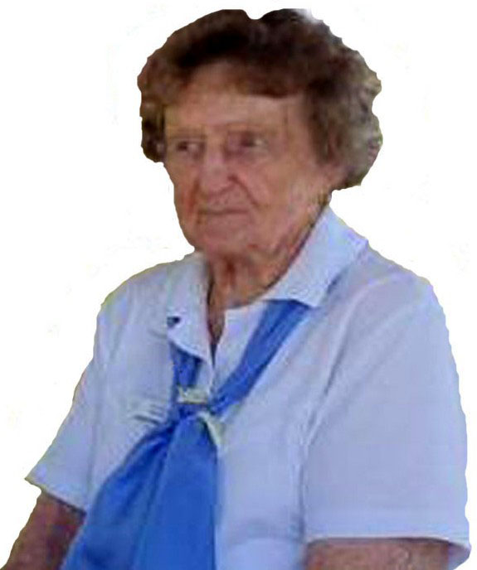  Heather was a member of our Club since 2021 and she passed away at the grand age of 99  RIP Heather  Annual Christmas Party  7th December @  The Diggers @ The Entrance  Coming along for an enjoyable get together to celebrate Christmas  We will enjoy a 3 course lunch with the first drink free  11:30 Start  Cost $60 pp  Dance away to the tunes of the duo “Brassick”  This Year’s Charity is Merrilyn Self’s  “Bags of Dignity”  For this year Merrilyn has on sold Material bags which she hopes will come back filled with suitable bits and pieces that will assist someone in need.  Merrilyn will collect all bags at the October Meeting.  Please make sure that you include a slip of paper with your name
  Cash Balance | 30,346.32
  Plus Income | 10,530.00
  Less Expenditure | 2,060.37
  Cash Balance | 38,815.95
  Plus Deposits to Suppliers | 1,300.00
  Less Members pre-payments | - 31,200.00
  Available funds | 8,915.950
EDITOR’S NOTE: This is an edited version of Newsletter #397 due to space limitations on the Club Website

